Task -5

Set up a VPC with an Internet gateway, create a public subnet with 256 IP addresses, a private subnet with 256 IP addresses, make a route table connecting the Internet gateway and the subnets, and launch a Linux EC2 instance by using the above VPC and public subnet.

1. Create VPC.

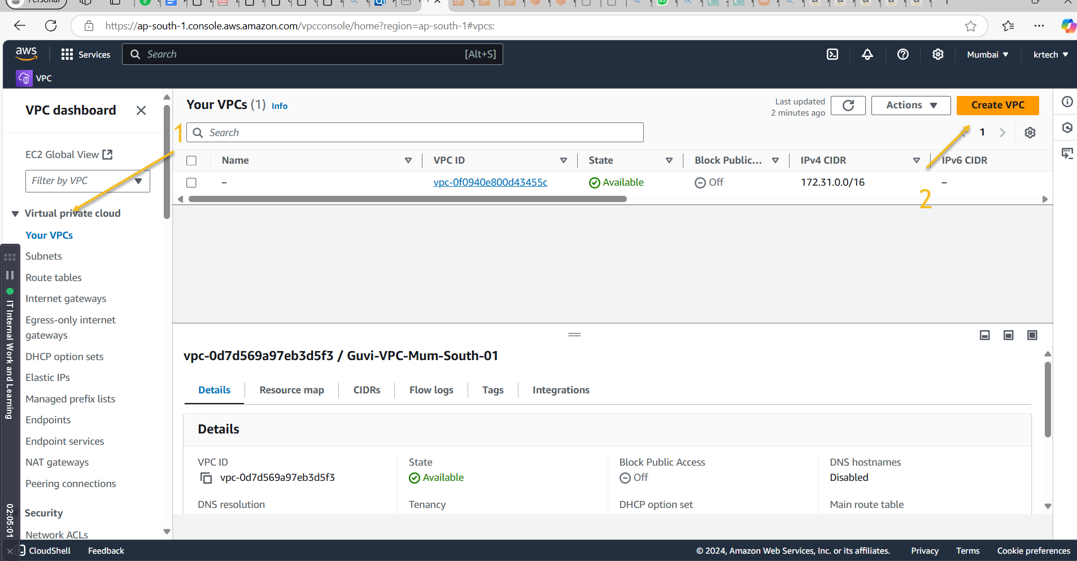

Give a name, Mention the IPv4 CIDR as 10.0.0.0/16, and the hit create.

1. create a public subnet with 256 IP addresses.

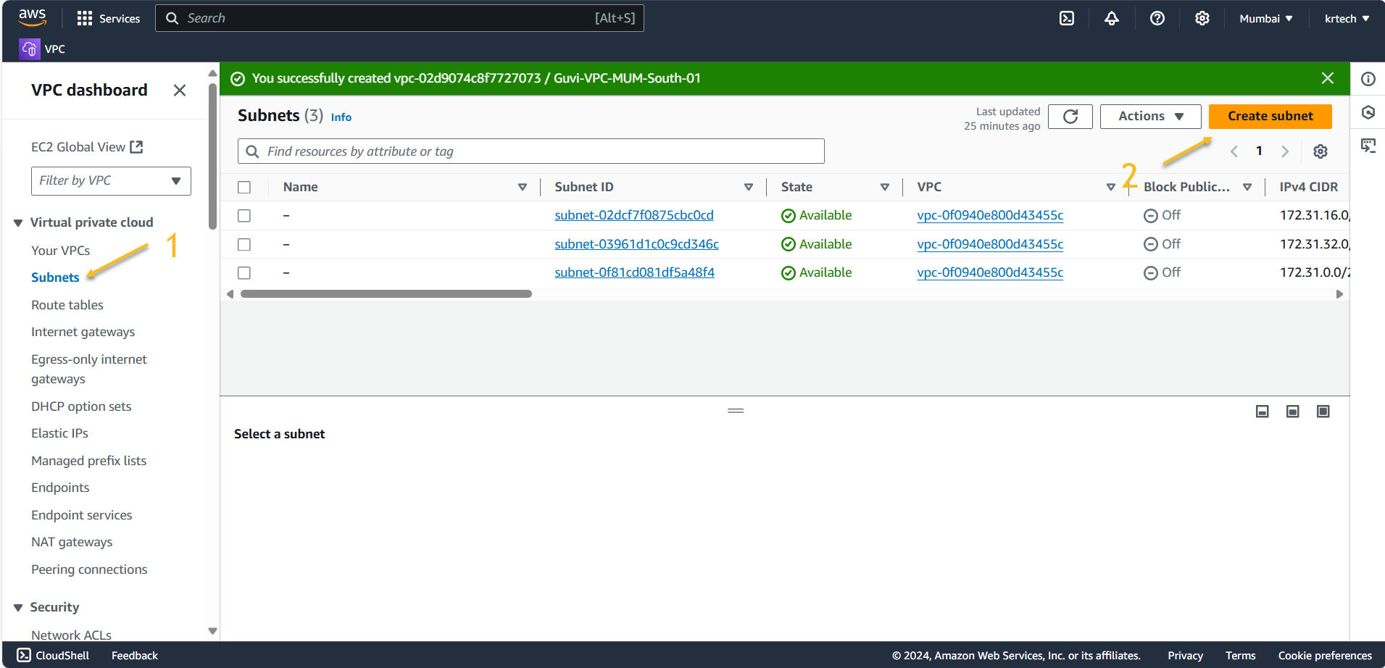

Create subnet 🡪 select the VPC 🡪Give the subnet name 🡪Select the availability zone 🡪 Assing the IP range we want for the IPv4 subnet 🡪 hit create.

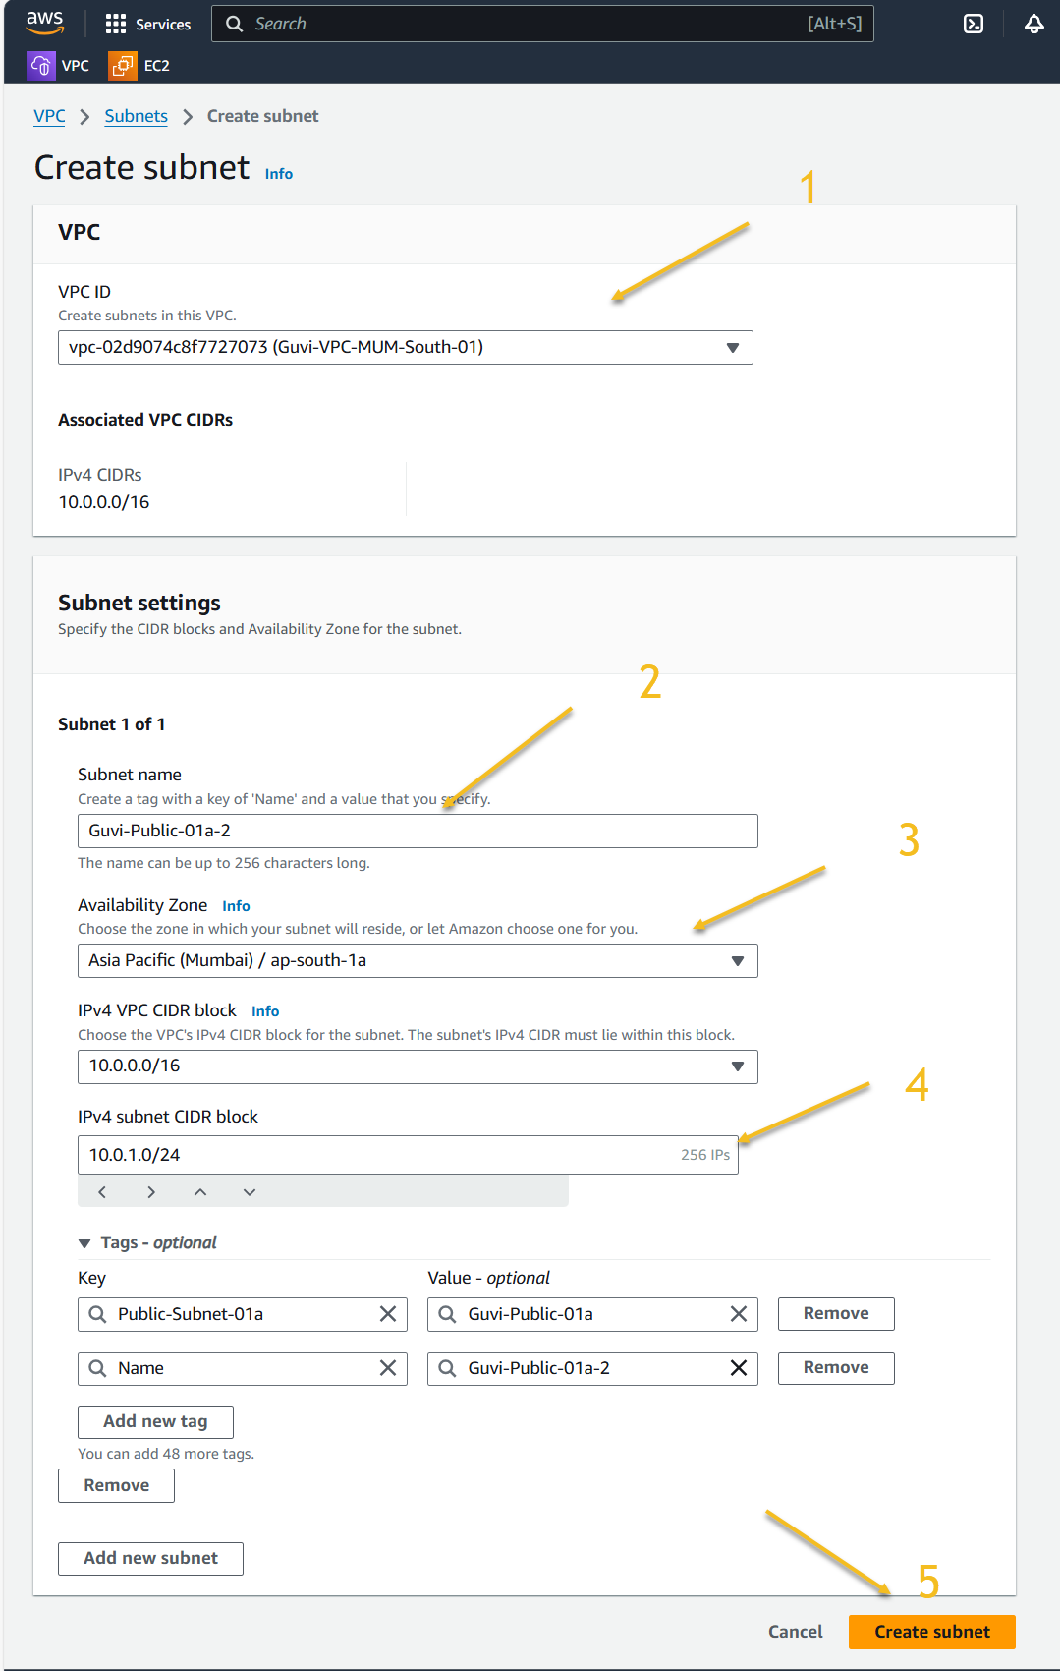

1. a private subnet with 256 IP addresses

do the same steps for Private subnet as well.

1. make a route table connecting the Internet gateway and the subnets

Create a Route table 🡪Assign the name 🡪 select the VPC🡪hit create.

Once the Route table is created, Go to subnet associations🡪edit subnet associations🡪

Select the subnet which we want to associate with the route table🡪 Save association.

For connect the VPC with Internet gateway, we need to create the Internet gateway first.

Give a name to Internet gateway 🡪 Hit create.

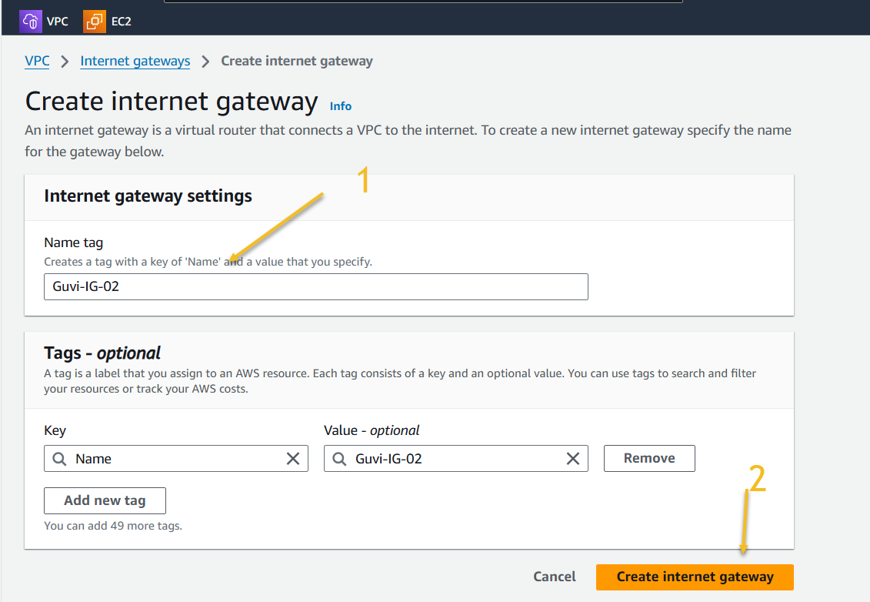

Once it created we need to attach it to VPC – >Goto action “Attach to VPC”

Select the VPC where we want to connect in Drop down and Attach internet gateway.

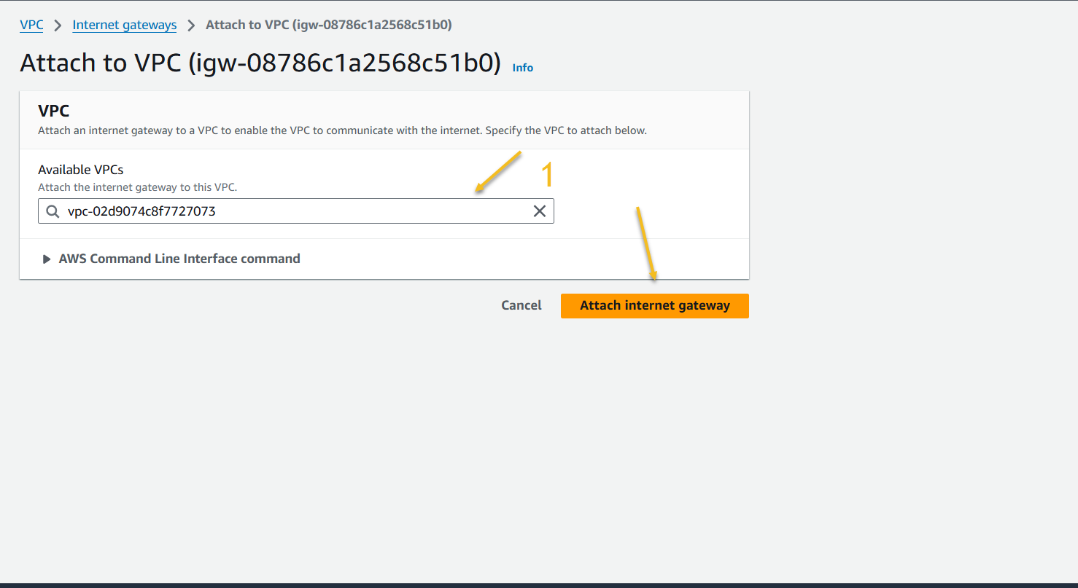

Once it attached, we can find the like this.

After attaching Internet gateway to VPC now, Edit the routes of our public subnet pointed Route table.

Select add route🡪 select internet gateway 🡪IG id🡪 save changes.

1. launch a Linux EC2 instance by using the above VPC and public subnet.

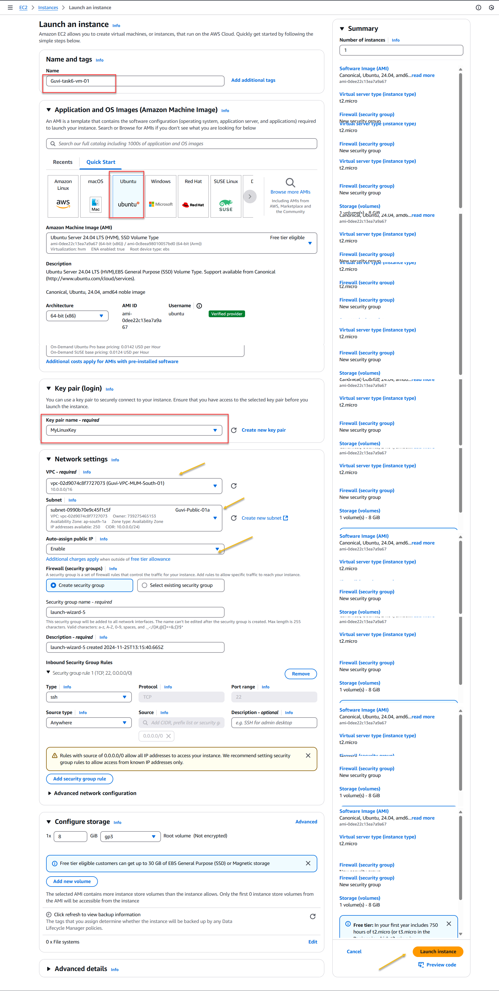

Finally, Launch the instance followed by the steps, Make sure select the created VPC with has Internet gateway attached to it.

